Revision Guides for KS4 Subjects – May 2026
SUBJECT: | DETAILS: | LINK TO BUY:
English Language | CGP AQA English Language Revision Guide | https://www.cgpbooks.co.uk/secondary-books/gcse/english/english-lang/enar42-new-gcse-english-language-aqa
English Literature | CGP Macbeth guide to the Text  CGP Romeo and Juliet Guide to the Text  CGP A Christmas Carol Guide to the Text  York Notes A Christmas Carol | https://www.cgpbooks.co.uk/secondary-books/gcse/english/english-lit/etm44-tbc-new-grade-9-1-gcse-english-shakespeare-t  https://www.cgpbooks.co.uk/secondary-books/gcse/english/english-lit/etr45-tbc-new-grade-9-1-gcse-english-shakespeare-t  https://www.cgpbooks.co.uk/secondary-books/gcse/english/english-lit/etcc42-tbc-new-grade-9-1-gcse-english-text-guide-a  https://www.yorknotes.com/gcse/english-literature/a-christmas-carol-2017/overview
Maths | CGP revision guide (higher or foundation) available from the Maths office for £3  Edexcel revision guide (higher or foundation) £5.99  Edexcel revision workbook (higher or foundation) £5.99 | REVISE Edexcel GCSE (9-1) Mathematics Higher Books  REVISE Edexcel GCSE (9-1) Mathematics Foundation Guided Revision Books
Combined  Science | GCSE Combined Science Course (Years 10 and 11)  Foundation Students (sets 2, 3 & 4)  Revision cards, at £8 per pack, can be found here https://www.cgpbooks.co.uk/secondary-books/gcse/science/combined-science/scaf41-gcse-combined-science-aqa-revision  Revision book, at £11, can be found here https://www.cgpbooks.co.uk/secondary-books/gcse/science/combined-science/scafs42-new-gcse-combined-science-aqa  Higher students (set 1)  Revision cards, at £8 per pack, can be found here https://www.cgpbooks.co.uk/secondary-books/gcse/science/combined-science/scaf41-gcse-combined-science-aqa-revision  Revision book can be found here, at £11, https://www.cgpbooks.co.uk/secondary-books/gcse/science/combined-science/scahs42-new-gcse-combined-science-aqa-higher
Separate Sciences | GCSE Separate Science Course (Years 10 and 11)  Biology revision cards, at £4.50 per pack, can be found here https://www.cgpbooks.co.uk/secondary-books/gcse/science/biology/baf41-9-1-gcse-biology-aqa-revision-question  Biology revision book, at £5.50, can be found here https://www.cgpbooks.co.uk/secondary-books/gcse/science/biology/bas46-new-gcse-biology-aqa-complete-revision  Chemistry revision cards, at £4.50 per pack, can be found here https://www.cgpbooks.co.uk/secondary-books/gcse/science/chemistry/caf41-9-1-gcse-chemistry-aqa-revision  Chemistry revision book, at £5.50, can be found here https://www.cgpbooks.co.uk/secondary-books/gcse/science/chemistry/cas46-new-gcse-chemistry-aqa-complete  Physics revision cards, at £4.50 per pack, can be found here https://www.cgpbooks.co.uk/secondary-books/gcse/science/physics/paf41-9-1-gcse-physics-aqa-revision-question  Physics revision book, at £5.50, can be found here https://www.cgpbooks.co.uk/secondary-books/gcse/science/physics/pas48-new-gcse-physics-aqa-complete-revision  If your child follows the Separate Science course, you have the option to purchase resources for all three sciences or just the ones your child feels they need more help with.  All separate science students should purchase the higher tier resources.
History | There are 3 options:  - These individual guides condense the textbooks we have used in lessons. They are well laid out and have lots of pictures and charts etc to display the information.  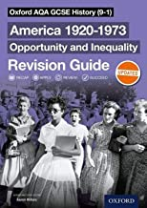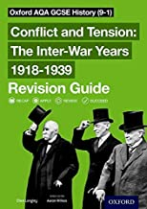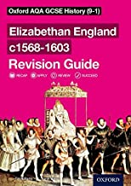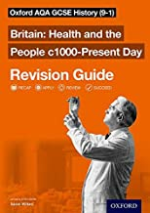  - This book has all 4 components of the course included. It is denser text and has fewer pictures, diagrams etc.  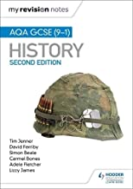  - These are new 2026 – workbooks that have all the content and activities to practise content and essay skills.  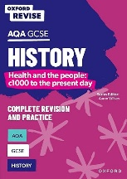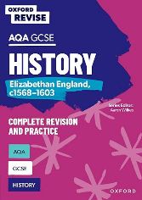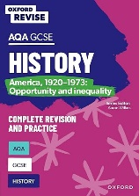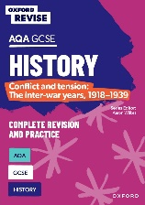 | They are all available on Amazon:  Amazon.co.uk: Gcse Aqa Revision Guide HISTORY  Amazon.co.uk: Gcse Aqa Revision Guide HISTORY  Amazon.co.uk: Gcse Aqa Revision Guide HISTORY  Amazon.co.uk: Gcse Aqa Revision Guide HISTORY  Amazon.co.uk : gcse history aqa hodder  AQA GCSE History: Britain: Health and the people: c1000 to the present day: For the 2026 Exams (Oxford Revise: History): Amazon.co.uk: Power, Harriet, Wilkes, Aaron: 9781382053679: Books  AQA GCSE History: Elizabethan England, c1568-1603 Complete Revision and Practice: Knowledge, Retrieval, Practice: For the 2026 Exams (Oxford Revise: History): Amazon.co.uk: Martin, Paul, Wilkes, Aaron: 9781382053716: Books  AQA GCSE History: America, 1920-1973: Opportunity and inequality Complete Revision and Practice: For the 2026 Exams (Oxford Revise: History): Amazon.co.uk: Ball, James, Wilkes, Aaron: 9781382053655: Books  AQA GCSE History: Conflict and tension: The inter-war years, 1918-1939 Complete Revision and Practice: For the 2026 Exams (Oxford Revise: History): Amazon.co.uk: Martin, Paul, Wilkes, Aaron: 9781382053693: Books
Geography | The main resources we recommend are the CGP Complete Revision and Practice Guide and CGP Revision Question Cards:  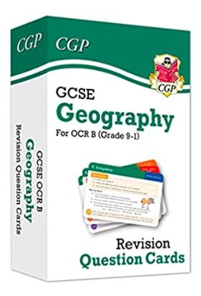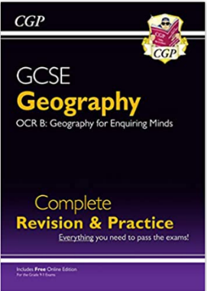  Or the Oxford Revise Complete Revision and Practice.  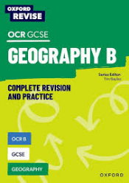  There are many other good revision books available, just ensure they are for the OCR B exam board. | They are both available on Amazon:  GCSE Geography OCR B Revision Question Cards: superb for the 2023 and 2024 exams (CGP OCR GCSE Geography) : CGP Books, CGP Books: Amazon.co.uk: Books  GCSE Geography OCR B Complete Revision & Practice (with Online Edition): superb for the 2023 and 2024 exams (CGP OCR GCSE Geography) : CGP Books, CGP Books: Amazon.co.uk: Books  OCR B GCSE Geography Complete Revision and Practice (Oxford Revise: Geography): Amazon.co.uk: Priest, Rebecca, Bayliss, Tim: 9781382039895: Books
French | New Edexcel revision guide and workbook available to order. | GCSE French Edexcel revision guide  GCSE French Edexcel revision workbook
German | New Edexcel revision guide and workbook available to order. | GCSE German Edexcel revision guide  GCSE German Edexcel revision workbook
Spanish | New Edexcel revision guide and workbook available to order. | GCSE Spanish Edexcel revision guide  GCSE Spanish Edexcel revision workbook
Business | Pearson REVISE Edexcel GCSE Business Revision Guide inc online edition and quizzes - 2023 and 2024 exams  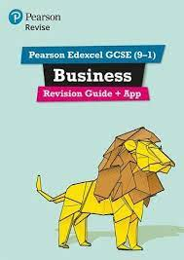  Pearson Edexcel GCSE (9-1) Business Revision Workbook  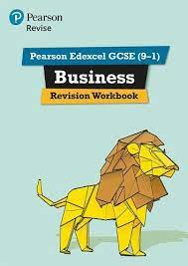  Pearson REVISE Edexcel GCSE Business Revision Cards  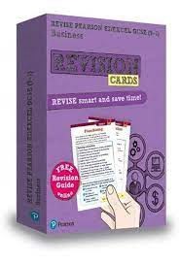 | Pearson REVISE Edexcel GCSE Business Revision Guide inc online edition and quizzes - 2023 and 2024 exams: for home learning, 2022 and 2023 assessments and exams (REVISE Edexcel GCSE Business 2017) : Amazon.co.uk: Books  Pearson Edexcel GCSE (9-1) Business Revision Workbook: Catch-up and Revise: for home learning, 2022 and 2023 assessments and exams (REVISE Edexcel GCSE Business 2017) : VV., AA.: Amazon.co.uk: Books  Pearson REVISE Edexcel GCSE Business Revision Cards (with free online Revision Guide) - 2023 and 2024 exams: for home learning, 2022 and 2023 assessments and exams (REVISE Edexcel GCSE Business 2017) : Redfern, Andrew: Amazon.co.uk: Books
Enterprise & Marketing | Cambridge National in Enterprise and Marketing Revision Guide and Workbook with Digital Access (2 Years): Level 1/Level 2 (Cambridge Nationals)  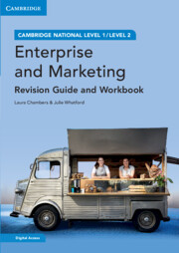 | Cambridge National in Enterprise and Marketing Revision Guide and Workbook with Digital Access (2 Years): Level 1/Level 2 (Cambridge Nationals) : Chambers, Laura, Whatford, Julie: Amazon.co.uk: Books
GCSE PE | Revision Book – AQA GCSE PE | GCSE Simplified - GCSE Physical Education, Revision Study Guide
Engineering TECH | Cambridge National Level 1/Level 2 Engineering Second Edition J822 ISBN: 978-1-3983-5033-5  All students have access to the online version  Engineering revision guide available through school for £3 25 (DT office). | Level 1/Level 2 Cambridge National in Engineering Design (J822): Second Edition: Amazon.co.uk: Adams, Jonathan, Valentine, Peter, Reynolds, Alex: 9781398350335: Books  Level 1/Level 2 Cambridge National in Engineering Design (J822) Exam Practice Workbook | Hachette Learning
Food Prep | AQA Food Preparation & Nutrition textbook (Illuminate Publishing)  Collins AQA Grades 9-1 Food Preparation & Nutrition ‘Complete Revision and Practice’ | FREE....school subscription paid for! Link on school homepage and students have log on details.  Collins GCSE Grade 9-1 Revision - AQA GCSE 9-1 Food Preparation & Nutrition Complete Revision & Practice: Ideal for home learning, 2023 and 2024 exams (Collins GCSE Grade 9-1 Revision): Second edition  £10.99
D&T (including the textiles option) | Students have a copy of this book already so there is no need to buy it. Their copy might currently be in school but they will be able to take it home to revise. If students do not have one they should see their D&T teacher.  Note: it is the same book for textiles and the ‘wood/metals/plastics’ courses. | Collins GCSE Grade 9-1 Revision - AQA GCSE 9-1 Design & Technology Complete Revision & Practice: Ideal for home learning, 2023 and 2024 exams (Collins GCSE Grade 9-1 Revision): Second edition
Media | Copies are available in K14/K15 to use in school (lunch time or after school). | https://www.illuminatepublishing.com/product/wjec-eduqas-gcse-media-studies-student-book-revised-edition
RE | This is a very good and up-to-date resource. Students do not need to buy their own copy – we will provide them with one. | AQA GCSE Religious Studies A: Christianity and Islam (Exams from 2026): For the 2026 Exams (Oxford Revise: Religious Studies): Amazon.co.uk: Cox, Dawn: 9781382073448: Books
Computer Science | 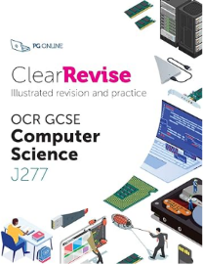  An updated version for the J277 course - £8 | https://www.amazon.co.uk/ClearRevise-GCSE-Computer-Science-J277/dp/1910523232/ref=sr_1_1?crid=VOV03FC4WH5H&keywords=clearrevise+ocr+computer+science+j277&qid=1697530749&sprefix=ClearRevise+J277%2Caps%2C104&sr=8-1
GCSE Dance | Various online resources, links attached | https://www.rbo.org.uk/schools/resource/infra-gcse-dance-resources - Infra resource pack  https://studyrocket.co.uk/revision/gcse-dance-aqa - study rocket  https://www.jamescousinscompany.com/product-page/scheme-of-work - Within Her Eyes  https://rambert.org.uk/classroom/appreciate/aqa-set-works/a-linha-curva/a-linha-curva-gcse-resource-pack/a-linha-curva-resource-pack/ - A linha Curva resource pack  https://arts-pool.co.uk/product/guide-to-artificial-things/ - Artificial Things
Sport Science | Revision materials for R180 | Sport Science 2022 | GCSE Simplified
GCSE Music | Edexcel / Pearson GCSE 9-1 in Music  Anthology – the written score for the music that is studied  Edexcel / Pearson GCSE 9-1 in Music Student book – the content (what students need to know about the music that is studied)  These are expensive and useful – but not essential. Students will be given handouts and resources in class that cover the content. We also have a class set of these that students work with in lessons.  CGP GCSE Edexcel Music Revision and Practice Guide. This is a useful resource for revision and practice for the listening exam | https://www.pearsonschoolsandfecolleges.co.uk/secondary/subjects/music-secondary/edexcel-gcse-9-1-music/edexcel-gcse-9-1-music-student-book-1?srsltid=AfmBOooKbnP7ZSXiAzw1T-HebugR8a0cN_GV0yA8p_ehB0DHJsZ-aG6Z  https://www.pearsonschoolsandfecolleges.co.uk/secondary/subjects/music-secondary/edexcel-gcse-9-1-music/edexcel-gcse-9-1-anthology-of-music-1#products  https://www.cgpbooks.co.uk/secondary-books/gcse/music/mues42-gcse-music-edexcel-complete-revision?srsltid=AfmBOop1qZbjbwbvl7Da5pVrZqXXQA_QPm3xTXUNiYx8Lu-HFdwvlfnB
GCSE Drama | Various revision guides available | OCR GCSE (9-1) Drama By Annie Fox| World of Books GB  GCSE Drama Revision Guide | CGP Books  Blood Brothers York Notes GCSE English Literature Study Guide - for 2026, 2027 exams By David Grant| World of Books GB
BTEC Performing Arts | Resources available online | Performing Arts (2022) | BTEC Tech Awards | Pearson qualifications

